

**EVENT FACILITATOR: ANNETTE PEDERSEN PH: 0468378716**

**BRAHMA KUMARIS.ORG.AU**

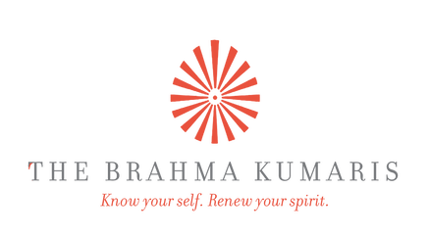

**A workshop experimenting**

**with manifesting the voice**

**of soul consciousness into**

**our communication for**

**uplifting self and others**

**Venue:**

**Solaris Cancer Care Centre**

**80 Railway Street**

**Cottesloe, 6011**

**(08) 9384 3544**

**VOICE OF THE SOUL**

The Art of Positive Communication

**DATE 12 October, 2024 09.30 – 1PM (incl. refreshments)**

BK Meditation Centre

15 Mills Street

Cannington 6107

0491 006 803

A workshop experimenting

with manifesting the light of

soul consciousness into our everyday

voice for uplifting self and others